**ExperimentNo.1.6**

**Student Name:** Gaurav Kumar **UID:** 22MCC20177

**Branch:** MCA**–**CCD **Section/Group:** MCD-1/A

**Semester:** III **Date of Performance: 8**th Oct 23

**Subject Name:** DevOps Process Automation Lab **Subject Code:** 22CAP-745

1. **Aim/Overview of the practical:**
2. Write a Scripted Pipeline to execute the build pipeline with all the 9 goals of Maven.
3. Execute the Scripted Pipeline via Scripted Pipeline with SCM. Name the file as Jenkinsfile and build a pipeline.
4. **Steps for practical: (a)**
5. A screenshot of a computer

   Description automatically generatedCreate a new file in the root directory of your project. Name the file as Jenkinsfile and add the pipeline script for 9 maven goals.

**Steps for practical: (b)**

1. To create a scripted pipeline via Jenkins SCM. First create a new pipeline by clicking on **“+”** icons on the Jenkins dashboard.
2. 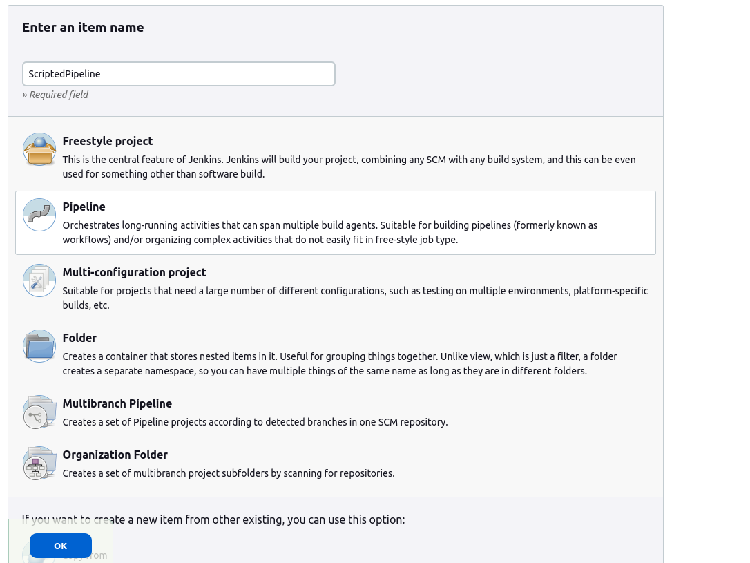A new window will appear select **pipeline** option from menu and give a name to your pipeline and then click on OK.
3. A new window will appear from which you can configure the create pipeline by providing scripts and selecting options.
4. Go to the Pipeline Section and select Pipeline script from SCM from the drop-down menu for the **pipeline Definition.**
5. For SCM option select Git and provide repository URL and branch name.
6. 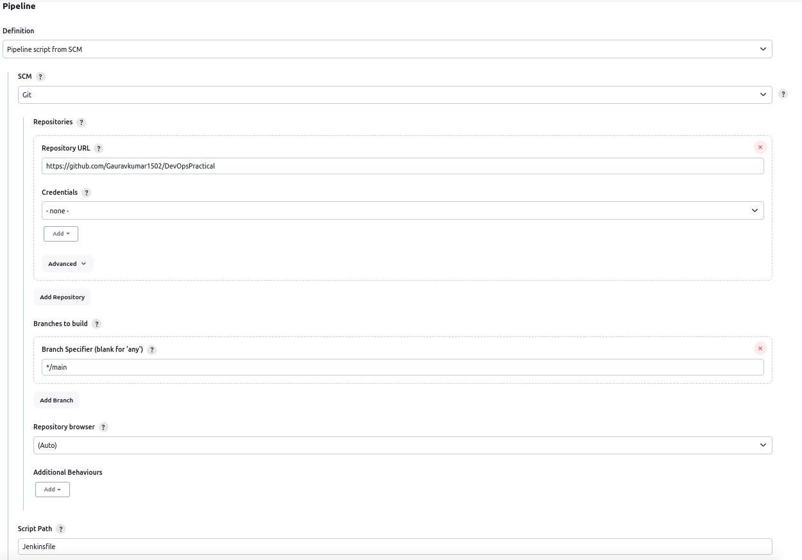After all that give the Jenkins file name that is present inside your project (case sensitive) under **Script Path** and click **Save.**
7. After that, from the right-hand side menu click on **Build Now** option.
8. 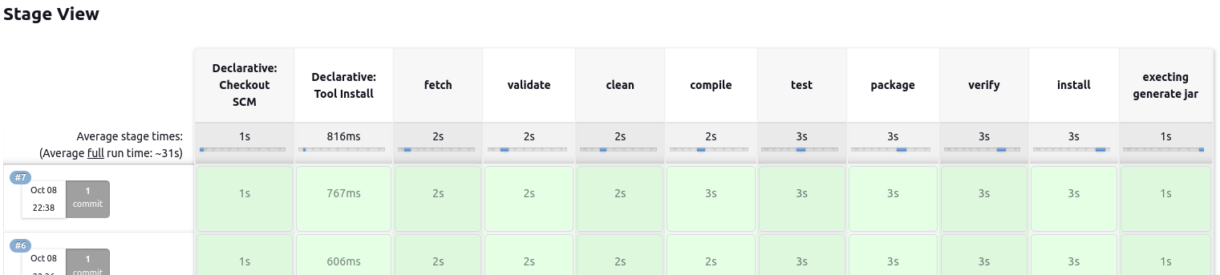If build success or fail, you will see a green or red indicator.